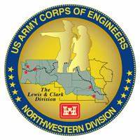
Columbia River System (CRS) Fish Facility Design Review Work Group (FFDRWG)

USACE, Portland District (NWP) and Walla Walla District (NWW)
  - January 2024 Meeting Notes
Meeting Date: January 4, 2024, 09:00-12:00
FFDRWG Meeting Files:
https://pweb.crohms.org/tmt/documents/FPOM/2010/FFDRWG/FFDRWG.html

Attendance
BPA
Scott Bettin
Christine Petersen
Greg Smith
Leah Sullivan
Ben Hausmann
Carolina Andes
NOAA
Blane Bellerud
Gabriel Brooks
Trevor Conder
Claire McGrath
Kelsey Swieca
Chris Magel
Kinsey Frick
Dana Bethea
USFWS
Dave Swank
Shelby Fowler
Joe Skalicky
States
Erick Van Dyke (ODFW)
Ben Clemens (ODFW)
Charles Morrill (WDFW)
Jonathan Ebel (IDFG)
CRITFC/Tribes
Tom Lorz (CRITFC)
Laurie Porter (CRITFC)
Greg Silver (CRITFC)
Casey Baldwin (CTCR)
Michael Karnosh (CTGR)
Lawrence Schwabe (CTGR)
Torey Wakeland (CTGR)
Aaron Jackson (CTUIR)
Ralph Lampman (YN)
Tod Sween (NPT)
NPCC
Kris Homel
FPC
Erin Cooper
Noah Campbell
PSMFC
Darren Chase
Roger Clark
Mark Leonard
Scott Livingston
Nicole Tancreto
Don Warf
CENWD
Doug Baus
Tim Dykstra
Dan Feil
Cindy Studebaker
Lisa Wright
Sean Tackley
Ian Chane
CENWP-PM
Ida Royer
Erin Kovalchuk
Brad Eppard
Nathan McClain
Jake Macdonald
Jon Rerecich
David Trachtenbarg
Scott Fielding
Rebecca Cates
CENWP-OD
Andrew Derugin
Jeanette Flemmer
Tucker Gossett
Jase Owens
Bob Cordie
Jeff Randall
Jim Day
Aaron Young
Eric Grosvenor
Michael Lotspeich
Laura Rickets
Noah Strong
Tammy Mackey
Robert Wertheimer
Patricia Madson
Darren Gallion
Kyle Tidwell
CENWP-ENC
Adam Jones
Adam White
Brandt Bannister
Shari Dunlop
Chris Motti
Steve Schlenker
Max Wilson-Fey
Collin Porter
Dan Penn
Aaron Litzenberg
Mehdi Roshani
Cole Marfise
CENWW-PM
Chuck Barnes
Steve Juhnke
Steve Sipe
Ricardo Walker
Brad Trumbo
Liana Aker
Michael Erickson
CENWW-OD
Chris Peery
Denise Griffith
Elizabeth Holdren
Ken Fone
Bobby Johnson
Deb Snyder
CENWW-ENC
Jon Renholds
Sean Milligan
Ryan Pestes
Travis Foster
John Lomeland
Ryan Laughery

Action Items from this meeting
- Macdonald: NWP BON2 FGE will be removed from future FFDRWG agendas.
- Macdonald: Jake will schedule a tour of The Dalles LPS in conjunction with the AFEP annual review on the morning of January 23rd.
- Macdonald: Jake will schedule a Webex call for interested FFDRWG and FPOM participants with relevant experience to help CRITFC/Tribes develop a video monitoring plan for when the floating lamprey collector prototype is being tested at The Dalles Dam.

Action items from previous meetings
- Chuck will provide presentation at next FFDRWG meeting outlining the path forward for LSR hydraulic cylinder installations.
  - See 5.10 below
- Grosvenor: John Day has the old collection tank from the NFL LPS and other surplus tanks available, Eric will send pictures.
  - Corps-Tribal Lamprey Workgroup visited John Day Dam on 11/29 to look at surplus tanks in person. CTLAW/FFDRWG members in attendance: Lyman Jim (CTWS), Ray Ellenwood (NPT), Ralph Lampman (YN), Greg Silver (CRITFC), Erin Kovalchuk (NWP), Eric Grosvenor (NWP). Tanks are available for CRITFC/Tribes to modify and use to support floating collector prototype testing.
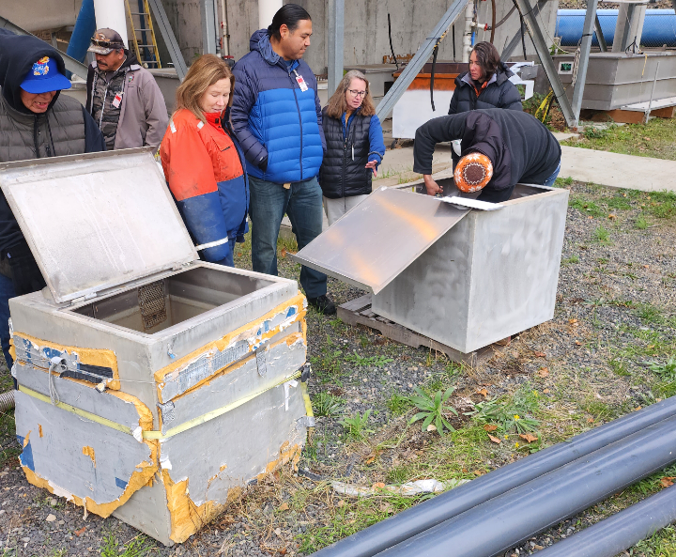
- Rerecich will advise where O&M considerations are discussed in the TDA Backup AWS debris management EDR.
  - Assumed to be complete.
- Jake will post B2 control section redesign 90% Plans & Specifications to FFDRWG meeting files for those interested.
  - Done. See link above.

NWP Topics for FFDRWG Update/Review/Coordination

NWP BON Spillway rock mitigation – Cpt. Adams (PM), Adam Jones (TL), Rebecca Cates (FFDRWG)
- CFD modeling is complete for the barriers and their deadweight anchor requirements, design will remain the same. Working toward 60% DQC and FFDRWG review.

NWP BON1 PIT Detection – Mark Bierman (PM), Jeanette Flemmer (FFDRWG)
- Design work is underway. Final, approved design expected in September of 2024.
- FY24 design work is funded. FY25 budget for installation support and EDC phase is being developed.

NWP BON2 FGE – James Smith (PM), Max Wilson-Fey (TL), Jon Rerecich (FFDRWG)
- Construction complete. Moving to the evaluation phase. This project will be removed from future FFDRWG agendas.

NWP TDA Backup AWS debris management – Cpt. Adams (PM), Mehdi Roshani (TL), Jon Rerecich (FFDRWG)
- Starting DDR phase.

NWP BON1 adult lamprey passage improvements – Erin Kovalchuk (PM), Adam White (TL), Jake Macdonald (FFDRWG)
- Construction underway. No issues to report.
- RL: Where are PIT antennas going? AD: There are two gaps in the bollard field for PIT antennas, one near the entrance weir and one near the base of the LPS ramp.
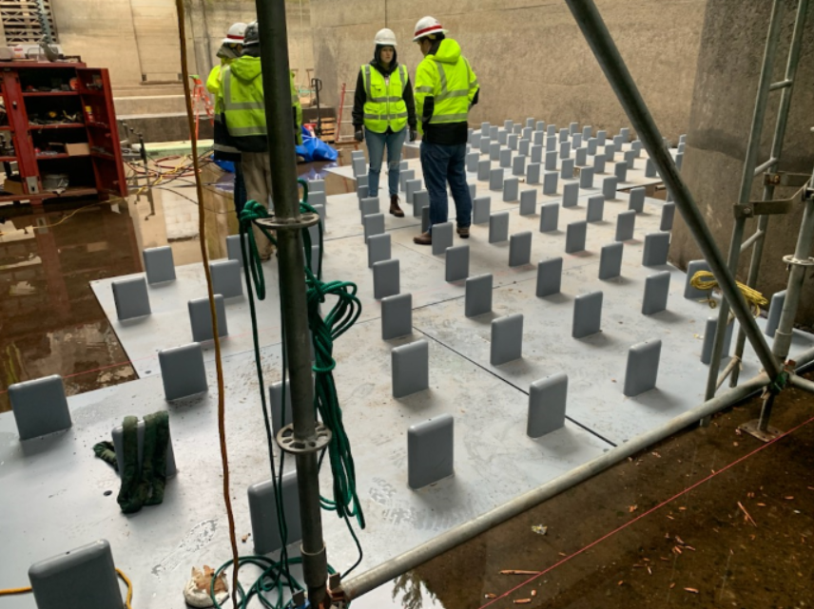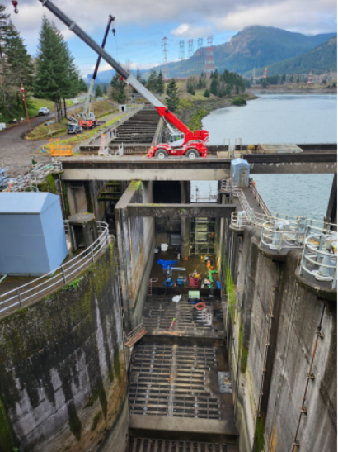

NWP BON2 control section redesign – Erin Kovalchuk (PM), Adam White (TL), Jake Macdonald (FFDRWG)
- 90% Plans and DDR are available on FFDRWG website.
- Working toward construction contract award summer 2024 for winter 2024-2025 construction.

NWP TDA adult lamprey passage improvements – Erin Kovalchuk (PM), Adam White (TL), Jake Macdonald (FFDRWG)
- Coming together nicely. No issues to report.
- LPS ramps and flumes are being installed. Commissioning tentatively scheduled for mid-January.
- Completed LPS should be available for interested FFDRWG members to tour the morning of January 23rd.
- Jake will schedule a tour of The Dalles LPS in conjunction with the AFEP annual review on the morning of January 23rd.
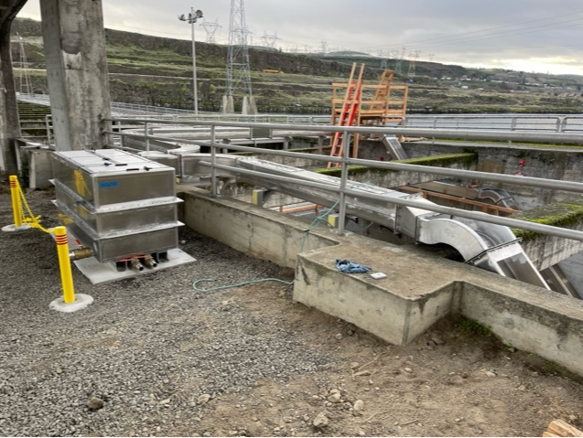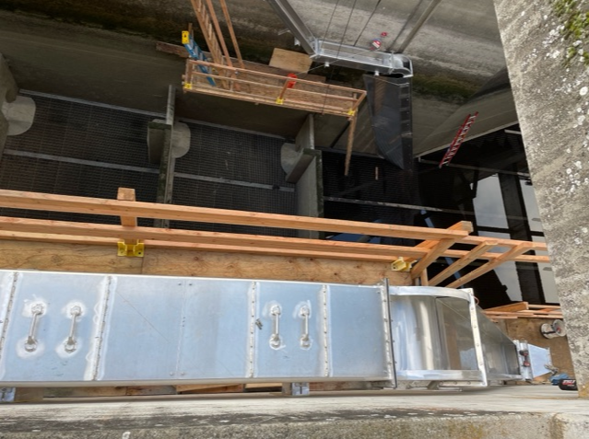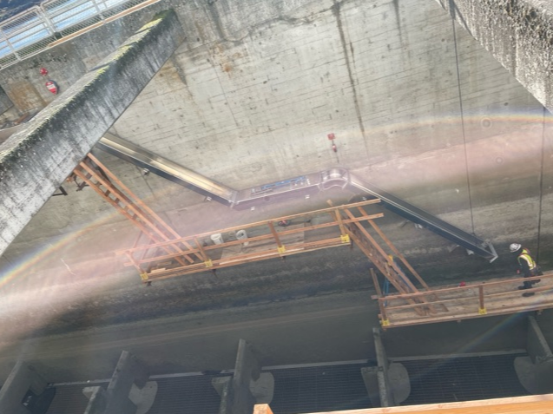

NWP JDA adult lamprey passage improvements – Erin Kovalchuk (PM), Adam White (TL), Jake Macdonald (FFDRWG)
- South entrance weir cap fabrication is close to complete, will be installed soon.

NWP TDA floating adult lamprey trap for tribal translocation (*partner project; not a USACE design) – Ralph Lampman (TL), Jake Macdonald (FFDRWG)
- CRITFC/Tribes intend to operate the floating trap in the Bonneville hatchery brood stock tanks during Spring 2024, until it’s ready for the river. When ready, CRITFIC/Tribes will move the trap to The Dalles Dam for “river trials” in the cul-de-sac and near the east entrance of the east fish ladder.
- Excerpt from CRITFC’s submitted research plan:
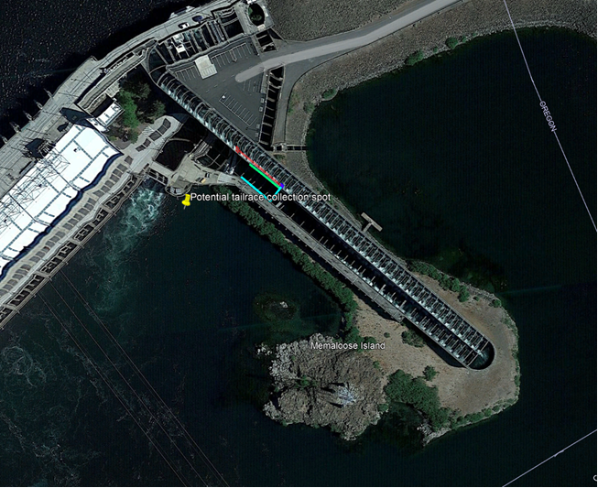
The Dalles floating trap deployment location (yellow pin). The adult floating trap will be placed in the water from the shoreline in June (to take advantage of higher tailwater) by CRITFC/Tribal staff (POC: Laurie Porter and Greg Silver, CRITFC; Ralph Lampman, YN) near the dock and operated in the general vicinity of the dock for a length of time before being towed around Memaloose Island to the location near the East entrance of the East Fish Ladder marked with the yellow pin for the peak of the run at TDA in July. The trap may remain in place until September, when it will be removed from the water by CRITFC/Tribal staff (POC: Laurie Porter and Greg Silver, CRITFC; Ralph Lampman, YN).
- Some FFDRWG participants visited the hatchery on 12/20 to see the prototype. Key FFDRWG participants in attendance: Trevor Conder and Chris Magel (NOAA), Dave Swank (USFWS), Ben Hausmann, Leah Sullivan and Carolina Andes (BPA), Jase Owens and Jeanette Flemmer (NWP), Greg Silver (CRITFC), Lyman Jim (CTWS).
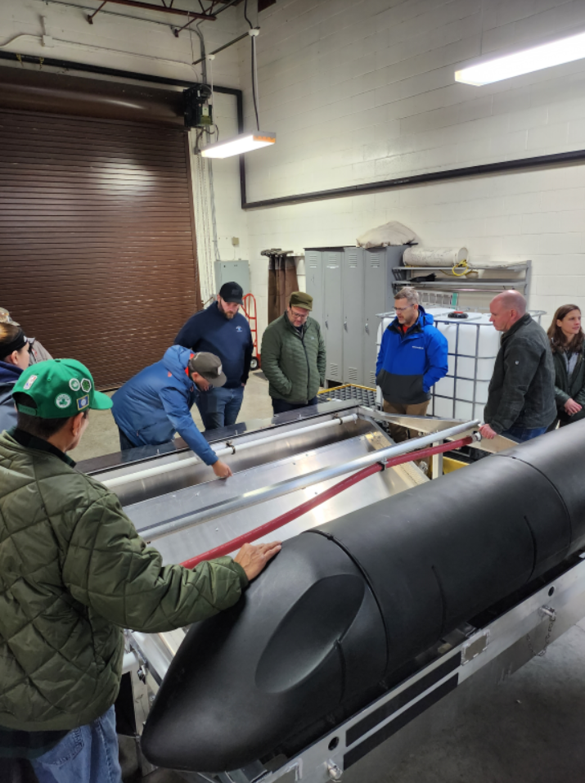
- RL: Can we go with 1.75” openings? TC: No. 1.5” or less in one dimension. Studies have shown anything wider is problematic. RL: Would like to see those studies.
- JM: What is the plan for video monitoring to ensure no negative effects on non-target species? RL: a go-pro camera mounted underwater. TC: You’re not going to have to access it? RL: Not unless something critical happens. TC: need something more than a go-pro, at least need a DVR to handle all the data. Reviewing ALL the video in sufficient detail would be impossible. Trevor wants to help the Tribes develop a reasonable monitoring plan, focused on critical periods of the run year.
- Jake will schedule a Webex call for interested FFDRWG and FPOM participants with relevant experience to help CRITFC/Tribes develop a video monitoring plan for when the floating lamprey collector prototype is being tested in the river.
- DS: Attraction flow may be insufficient. Suggests adding another attraction flow outlet. RL: most of the attraction will come from the ramp itself but may need to add another pump.
- JM: don’t forget about sea lion exclusion, even at The Dalles. At least one pinniped has been reported at The Dalles recently.

NWW Topics for FFDRWG Update/Review/Coordination

NWW IHR Turbine Unit Cooling Water Exclusion Structure- Steve Juhnke (PM), Liana Aker (Bio)
- Next available unit for installation is unit 6 in October 2024. Unit 1 was originally targeted but the turbine is being replaced and won’t be online until 2026.
- Survey crew did a laser scan of scroll case walls in November.
- Final design package for FFDRWG review in Jan-Feb 2024.

NWW MNA Turbine Replacement Design – Jean Desjarlais (PM), Jon Renholds (TL)
- No updates currently.

NWW LGA Adult Ladder Cooling Chimney Flap Gate- Steve Juhnke (PM), Chuck Barnes (Bio)
- Being fabricated in-house. Final cost estimate from divers is due tomorrow, will be done this IWW (by the end of Feb.)

NWW LLA Adult Ladder Turn Pool Gate- Greg Linklater (PM), Chuck Barnes (Bio)
- Design has been finalized. Installation to occur in 2025.

NWW Lower Granite cooling pumps – (PM yet to be determined)
- Chuck will follow up with Ryan L.
- CP: Major replumbing to get more cool water in (route water away from shower or replumb the shower). Working on it this winter.
- TC: two pumps are pretty important. Keep us in the loop.

NWW MCN Avian deterrence – Steve Juhnke (PM)
- Just kicking off. Using district A/E contract for an alternatives analysis. FFDRWG will review products. Will take a year before we could build anything.

NWW MNA PIT Detection – Steve Juhnke (PM)
- In-house effort. Kicking off alternatives analysis soon. Awaiting funding.
- TC: take a look at the stay agreement language, specific to the spillway.
- Gabe Brooks is funded by BPA and available to participate in the PDT.

NWW John Day Dam and Snake River Ladder Cooling – Steve Juhnke (PM)
- McNary, Lower Monumental, Ice Harbor, and John Day
- A/E contract to be awarded in March. Will take the full calendar year to complete EDR

NWW MNA Draft Tube Slot Filler – Jean Desjarlais (PM), Jon Renholds (TL), Chuck Barnes (Bio)
- See presentation from last month.
- Had to add a cross-member, will redistribute 60% design package for review.

LSR Hydraulic Cylinder Installations – Chuck Barnes
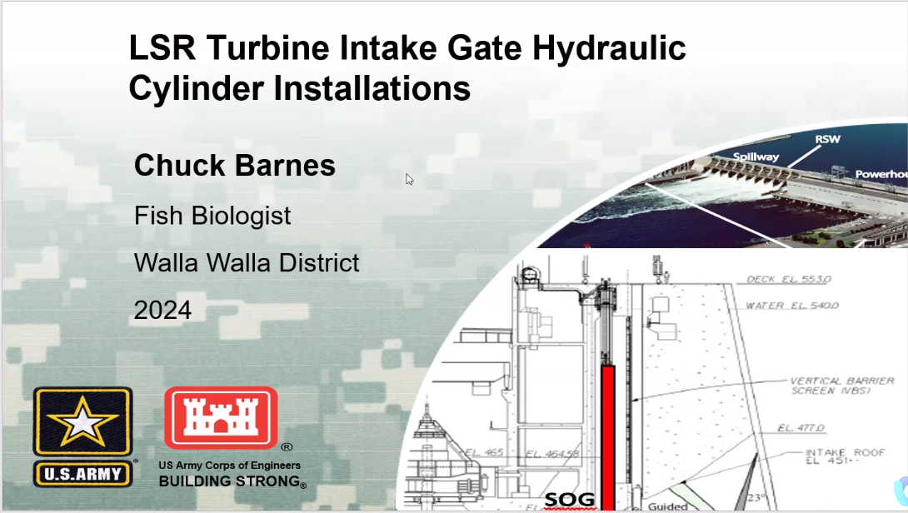
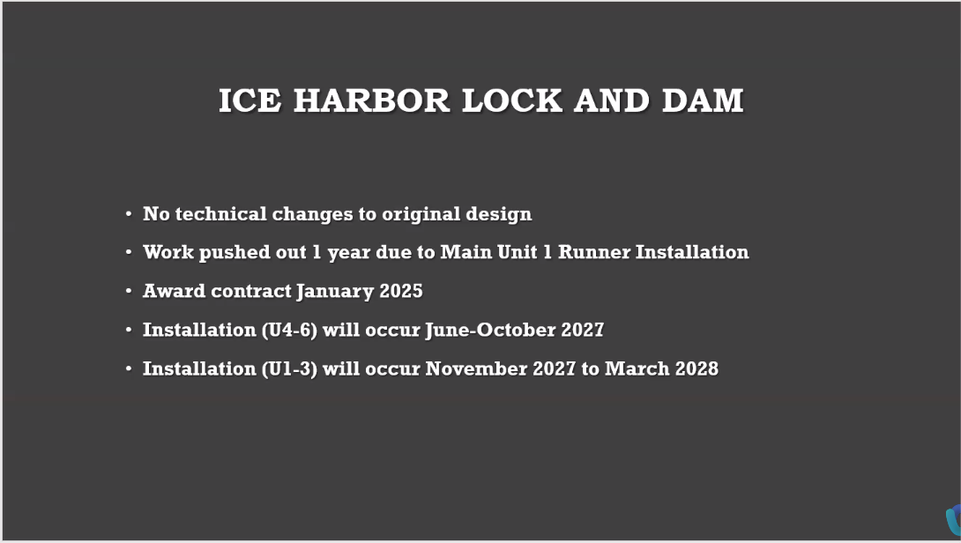
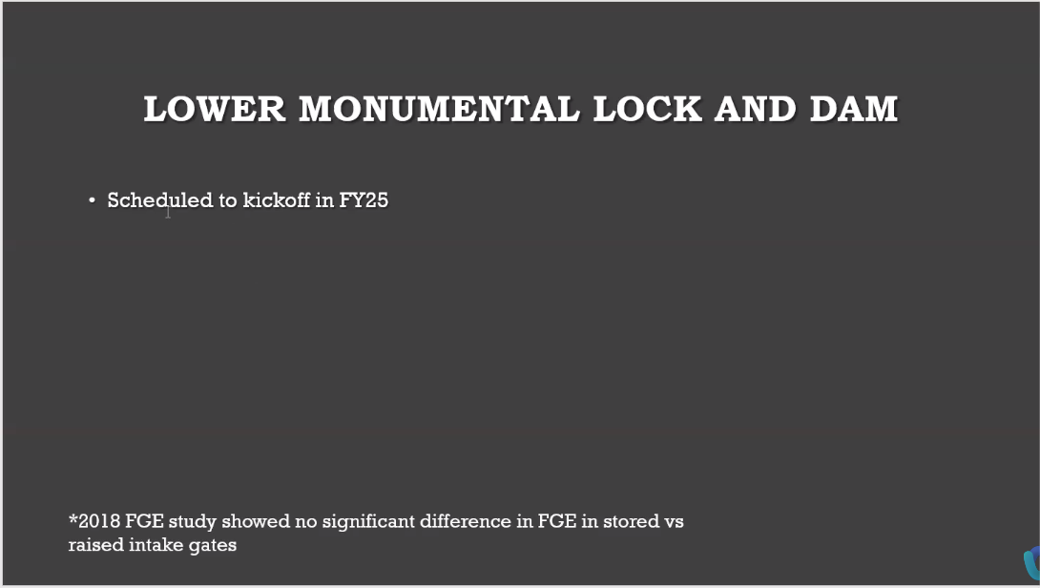
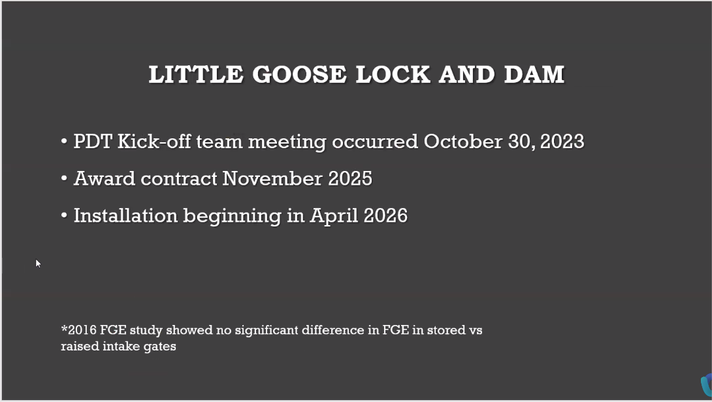
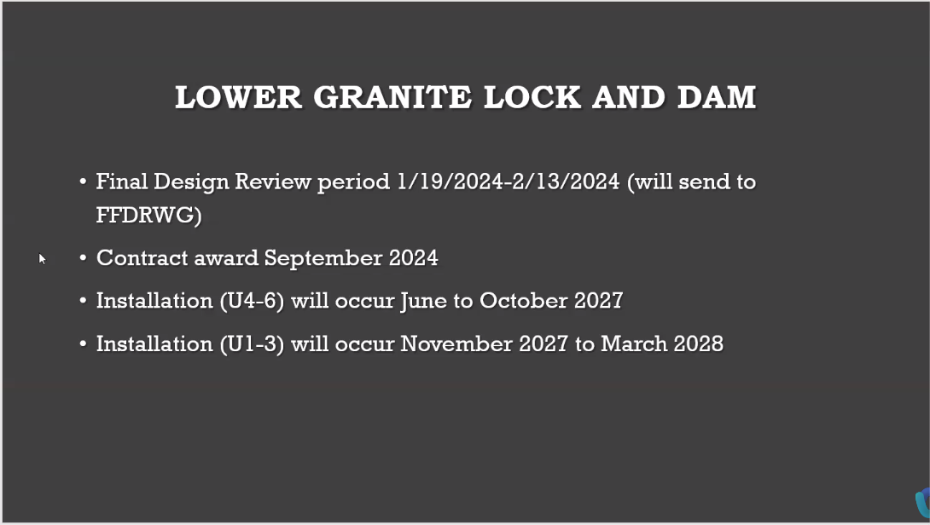

Upcoming meetings and field trips

FFDRWG and FPOM will not be combined again in the future.

Next regularly scheduled NWW/NWP FFDRWG meeting – Thursday, February 1st @ 09:00
  - Send suggestions for agenda items to Jake Macdonald and Chuck Barnes

Field trips to inspect dewatered fishways during in-water work window (December-January)
  - Bonneville Bradford Island Ladder – Did it. 12/20/2023.
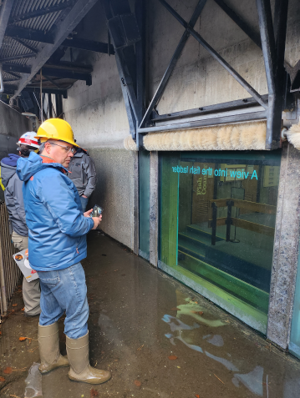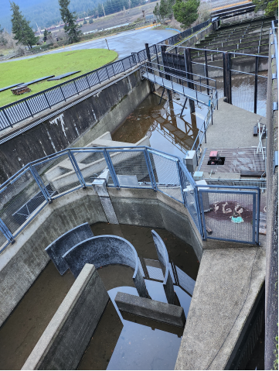
  - The Dalles East Fish Ladder – Jake will schedule in conjunction with AFEP annual review on the 22nd or 23rd of January.
  - Lower Granite Dam and fish ladder – Liana Aker is coordinating for January 16th. Contact Liana if you would like to attend.
  - Ice Harbor South ladder (morning) and McNary South ladder (afternoon) - Liana Aker is coordinating for January 17th. Contact Liana if you would like to attend.
  - Send suggestions for additional field trips to Jake Macdonald and Chuck Barnes

Field trip for FFDRWG and Corps-Tribal Lamprey Work Group to see floating lamprey collector in operation.
  - Partial day, In-person site visit to Tanner Creek hatchery – CRITFC/Tribes will schedule when they’re ready (April-May)
  - Partial day, In-person site visit to The Dalles Dam – Jake/CRITFC/Tribes will schedule when ready, later in the 2024 fish passage season.

Field trip for FFDRWG and Corps-Tribal Lamprey Work Group to see JDA adult lamprey passage improvements in operation.
  - Partial day, In-person site visit to John Day Dam – Jake will schedule during the peak of the 2024 fish passage season.

